MUJTABA SHAHID FAIZI

BSCS-5A

#131818

LAB 7 OF AP

Introduction: In this lab I updated my own implementation of the e-cafe from lab 6, and converted appropriate queries to PreparedStatement and CallableStatement form. JDBC drivers is included via Maven only.

Design & Approach: I have used java to implement a single class and added functions to calculate and display time, bill, orders etc. of users according to the opening and closing times of the café. I made a database with 5 tables using wamp and connected it with my java file using secured JDBC connection. I made a DOW layer for Food entity containing a function to search for a particular food item in the database. I have also entered in some data for the tables in the db.

In the DAO class (for Food table in my database: ecafe), I have created prepared statement and callable statements for executing queries. I created a procedure to output the name of the food items that have a particular id. Then I executed it with a callable statement. I created a prepared statement for a select query that asks for a particular price and returns the names of those food items having that price. Another prepared statement inserts the food values for name, id, amount, time_to_make, price in the food table.

How to Run & Analysis:

The menu list is displayed, and the user has to select the food item and its quantity. It will display the bill, time for order to take (factoring in all the previous orders) and then the next order will be waiting to be made. 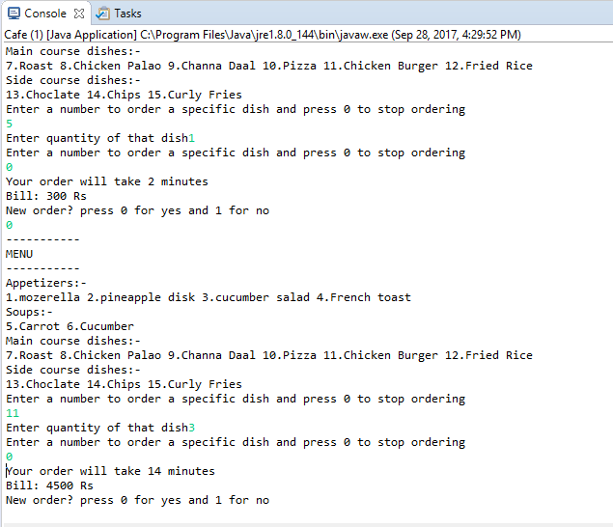

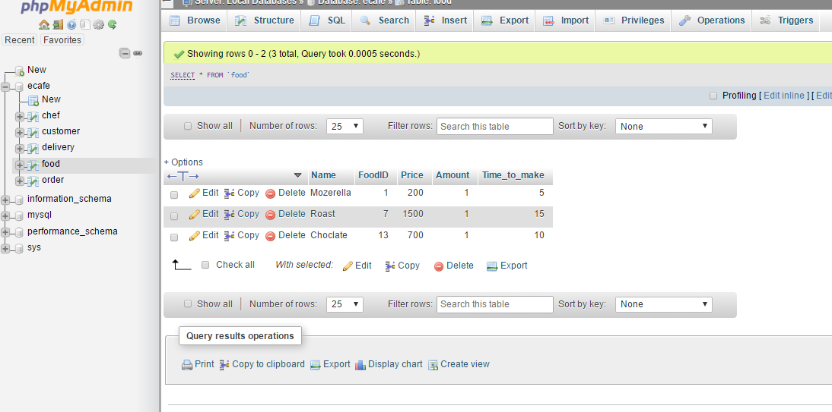

Running DAO package’s Food.java would ask the user to enter a food item to search in the restaurant and will output whether it is stored in the database or not.

Also, a query executed by prepared statement shows fooditems with price 45rs.

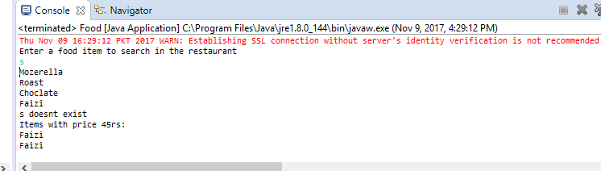

Another prepared statement inserts the food values for name, id, amount, time_to_make, price in the food table.

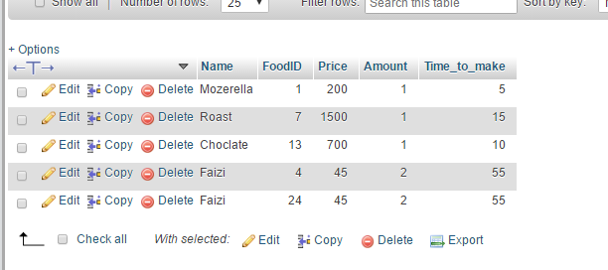

The callable statement gives the following output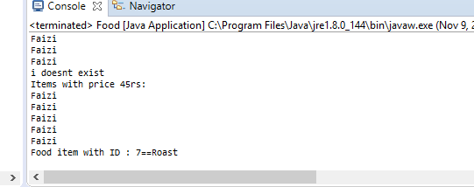

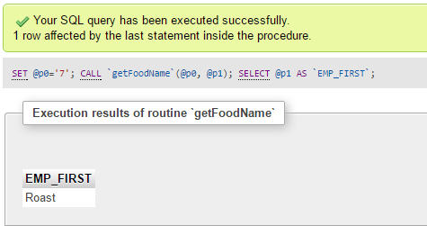

Link to the public repo on GitHub: https://github.com/mujtaba-faizi/Lab-7